Project Specification

Project# TR26-0037-BTS

Global Testing - India

Original Date: | 04/03/2026 | Revision Date: | DD/MM/YYYY | Revision No. | 00

Project Title | 70707 Seal Functional Test with Oil fill for Crankshaft Rear application for Simpsons
Requested By | Manjunath H R | Project Leader | Anoop N /Akshay K

Estimated Time for Project

Activity | Duration
Tooling Design, Manufacture and Inspection | Available
Testing (2 Seal 240 hours each) | 4 Weeks
Analysis & Reporting | 1 Week

* Test Seal samples shall be delivered to test center. It is preferred to receive the test samples along with Inspection report

Objective

To conduct the Endurance Test with Oil, fill on 2 samples seals for the purpose of validating the endurance of the seal 70707 with dust lip height variation for Crankshaft Rear application for Simpsons with the reference to the Test Request form# 2602-70707-Endurance test request_Rev1

Expected outcome from the Project

To check whether the seals fulfill the customer requirement of Functional Test with Oil fill, when tested as per the specification below.

Test Specification
Shaft:
Diameter : 133.30±0.030 mm
Surface Finish : 0.20 ~ 0.5 µm
Hardness : 30 HRC Min.
DRO : 0.200±0.025 mm TIR
Direction of Rotation : Counterclockwise

Bore:
Diameter : 158.750±0.038 mm
STBM : 0.25 ± 0.025 mm TIR
STBM Orientation : Minimum interference at 6 O’clock
Surface Finish : 1.6 ~ 3.2 µm Ra
Bore Material : Aluminum
Seal Cock : 0.00 ±0.025 mm
Reciprocation : NA

Fluid:
Type : SAE30
Temperature : Refer Test Cycle
Oil Change Interval : Nil
Oil Fill : Half Shaft
Pre-lube : 3 drops of oil on the shaft

Test Procedure :

- Measurement on samples before and after tests are tabulated below

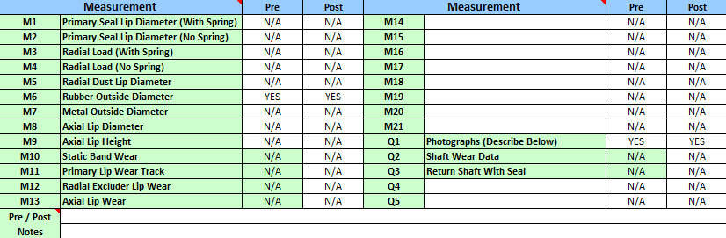
- Tolerance for Speed is ± 50 RPM and Temperature is ± 5°C

- Test cycle would be as follows

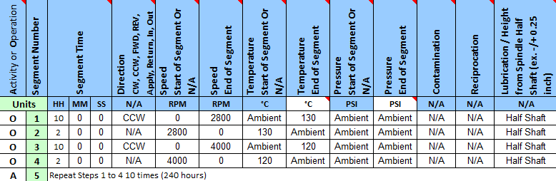
- Test setup and seal photographs shall be shared in the test report.

Acceptance Criteria:

Seal should pass 240 hours with a leakage < 3 g.

Decision Rule:

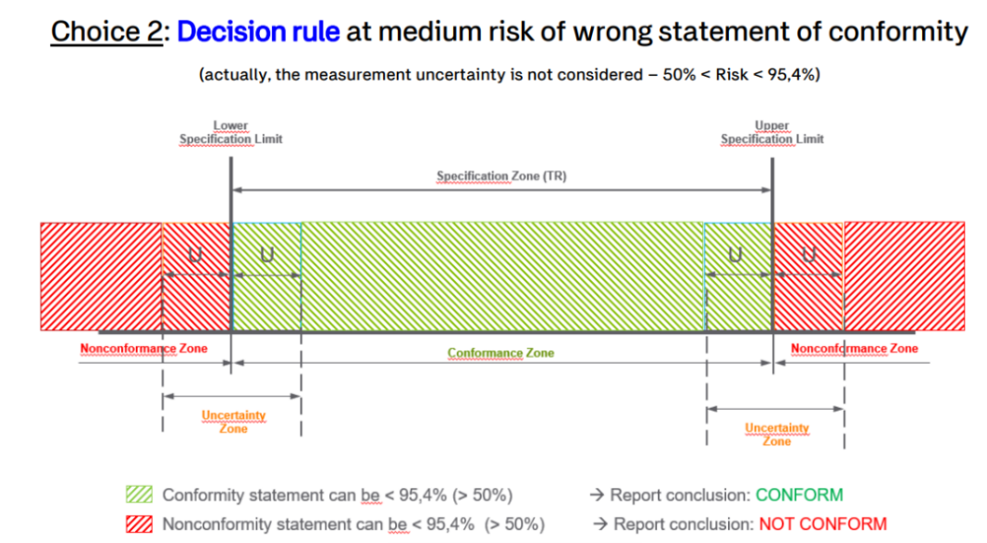

Part drawing:

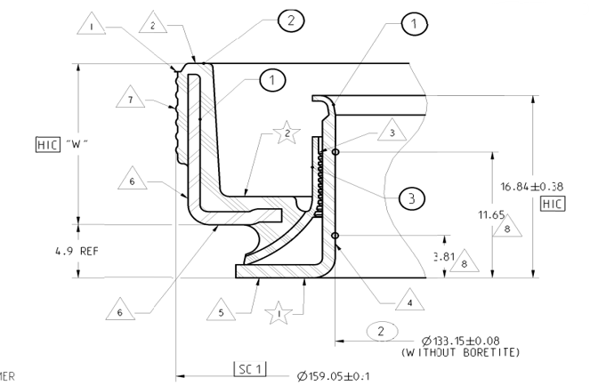

Assembly Tool:
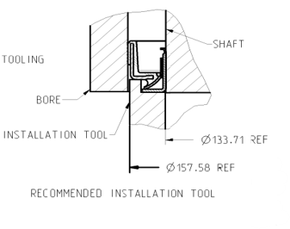

Procedure for monitoring:

- Each day in the morning between 8 a.m. and 9 a.m. to examine the seal (At the interference between the shaft OD and the seal ID, at interference between the bore ID and the seal OD) area for the oil leakage which constitutes a failure.
- On Friday of every week, the observation will be made again between 3.30 pm to 4.30 pm.
- During the weekend (Saturday & Sunday) and public holidays, the visual inspection cannot be done and any leakage found on the next inspection day, the total hours accumulated will be considered as the previous inspected completed hours.

Disclaimer:

- Seals dimensional results will be reported as actual and no inference will be made on the results.

